**Exploratory Data Analysis Lab**

**Code: PMDS604P**

**Digital Assignment 4**

**Name: Soumyadeep Ganguly**

**Reg. No.: 24MDT0082**

**Course: M.Sc. in Data Science**

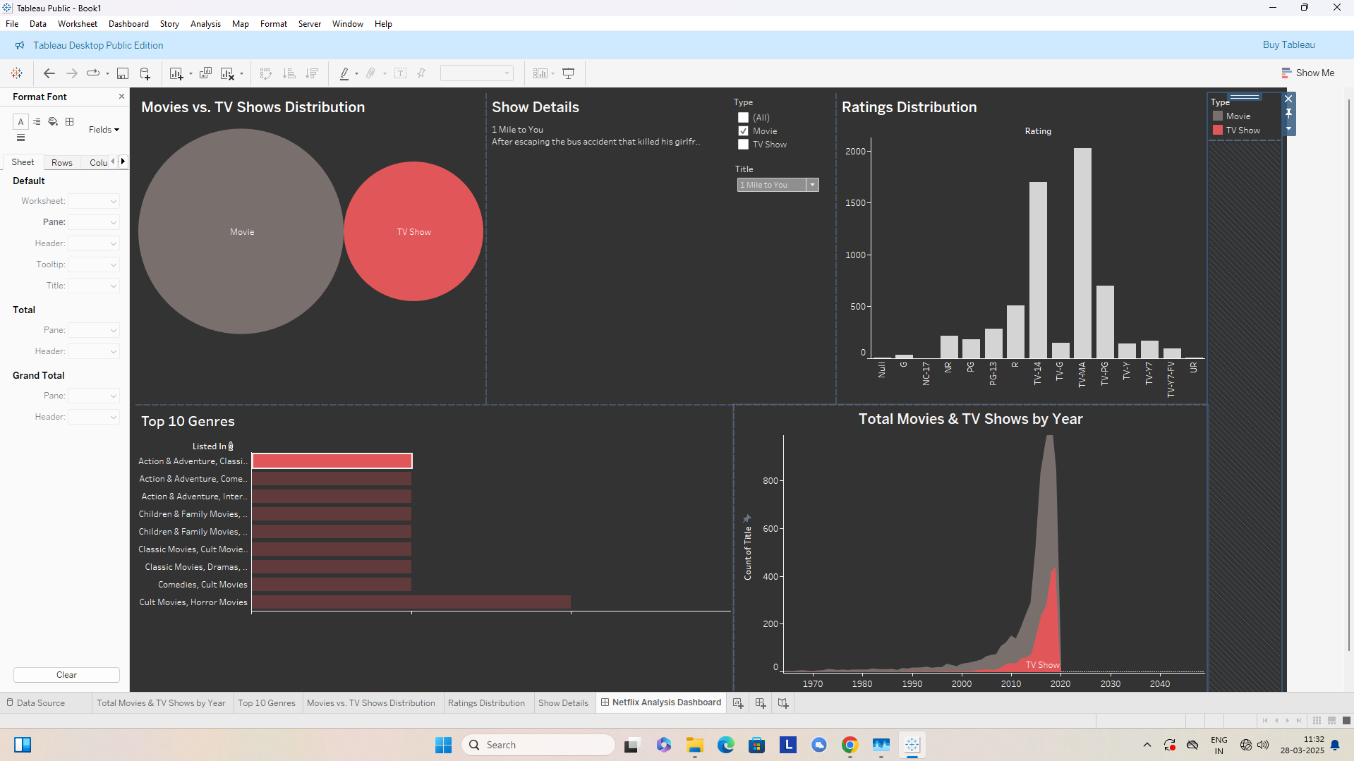**Tableau Dashboard: Netflix Data Analysis**

**Dashboard Components**

**1. Movies vs. TV Shows Distribution**

* This bubble chart visually represents the proportion of Movies and TV Shows available on Netflix.
* The larger bubble represents Movies, indicating they are more prevalent than TV Shows.
* TV Shows are represented by a smaller red bubble.

**2. Show Details Panel**

* This section provides detailed information about a selected title.
* The sample data displays the title *"1 Mile to You"* with a brief description.
* A filter option allows users to select between Movies, TV Shows, or both.

**3. Ratings Distribution**

* The bar chart shows the distribution of ratings across all titles.
* The majority of content is rated *TV-MA* and *TV-14*, indicating Netflix's focus on mature and teenage audiences.
* Less frequent ratings such as *NC-17* and *TV-Y* suggest fewer titles catering to those age groups.

**4. Top 10 Genres**

* This horizontal bar chart highlights the most common genres on Netflix.
* Action, Adventure, and Classic Movies dominate the top genres.
* The bars are color-coded, with red shades representing TV Shows and darker shades representing Movies.

**5. Total Movies & TV Shows by Year**

* This line graph shows the distribution of Movies and TV Shows released over time.
* The sharp increase around the 2010s suggests Netflix’s rapid expansion in content acquisition and production.
* The distinction between TV Shows (red) and Movies (grey) helps visualize the evolution of Netflix’s content strategy.

**Design Choices**

* **Dark Theme:** The dashboard utilizes a dark background to enhance readability and contrast. This dark & red theme is also inspired from Netflix colour-pallate.
* **Color Coding:** Red is used for TV Shows, while a neutral grey represents Movies.
* **Interactivity:** Filters and selection options allow users to explore specific insights.
* **Minimal Clutter:** The visualizations are arranged for clarity and easy interpretation.

**Conclusion**

This Tableau dashboard effectively highlights key insights into Netflix’s content library, illustrating trends in genre distribution, rating prevalence, and historical growth. The interactive elements allow for deeper exploration of the data, making it a useful tool for content analysis and strategic decision-making.

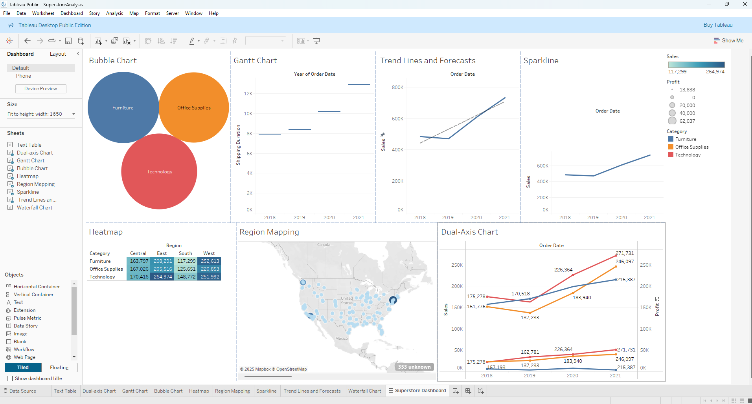**Tableau Dashboard: Superstore Data Analysis**

**1. Bubble Chart – Category-wise Sales Representation**

The **Bubble Chart** visually represents sales distribution across three major product categories:

* **Furniture (Blue)**
* **Office Supplies (Orange)**
* **Technology (Red)**

The size of each bubble indicates total sales, helping in quick comparisons. **Technology** appears to be a strong-performing category, while **Furniture** and **Office Supplies** have significant but slightly smaller contributions.

**2. Gantt Chart – Shipping Duration Trends**

The **Gantt Chart** displays the duration of order shipments across different years. It provides insights into how shipping times have varied over time. Analysing this can help optimize logistics and improve customer satisfaction.

**3. Trend Lines and Forecasts – Sales Growth Over Time**

This chart tracks **sales trends from 2018 to 2021** and includes a **forecasted trend line**.

* The solid line represents actual sales data, while the dashed line shows predicted future trends.
* The upward trend suggests consistent growth, reinforcing strong business performance over the years.

**4. Sparkline – Compact Sales Trend Representation**

The **Sparkline Chart** provides a minimalistic view of sales performance over time, allowing for quick trend recognition. The increasing trajectory reinforces the positive sales growth seen in the trend analysis.

**5. Heatmap – Regional Sales Comparison**

The **Heatmap** displays sales performance across different regions (**Central, East, South, and West**) for each category:

* **Technology** leads in sales across all regions.
* **Office Supplies and Furniture** follow closely, with varied performance across different regions.
* The color intensity helps in quickly identifying top-performing and underperforming regions.

**6. Region Mapping – Geographic Sales Distribution**

The **Region Mapping** chart visualizes sales distribution across the United States, with blue dots representing sales volume in different locations.

* Larger and darker dots indicate higher sales concentration, highlighting key sales hubs.
* This helps in identifying high-performing locations and potential areas for market expansion.

**7. Dual-Axis Chart – Sales and Profit Analysis**

This **Dual-Axis Line Chart** plots **sales (left axis) and profit (right axis)** over time:

* **Technology (Red)** consistently outperforms other categories in both sales and profit.
* **Office Supplies (Orange)** and **Furniture (Blue)** show steady growth but at a lower pace.
* The profit trends highlight potential areas where cost optimizations could improve margins.

## ****Conclusion****

This dashboard provides a clear **multi-dimensional analysis** of Superstore sales performance:  
✔ **Category-wise performance** – Technology leads in sales.  
✔ **Regional insights** – East and West regions generate the highest sales.  
✔ **Time-series trends** – Steady growth over the years with positive forecasts.  
✔ **Sales vs. Profit analysis** – Profits need optimization despite strong sales figures.

The well-structured dashboard allows for **data-driven decision-making** to improve sales strategies, optimize supply chain logistics, and enhance overall business performance.